**CubeSat Electronic Boards Design**

By:

A. Wong

J. Sands

K. Mody

P. Zwinkels

Faculty Advisor: Dr. Jayshri Sabarinathan

ECE 4416 Electrical/Computer Engineering Project

**Final Design Analysis and Test Report**

Department of Electrical and Computer Engineering

Western University

London, Ontario, Canada

# **1. Final Analysis of Design Concept**

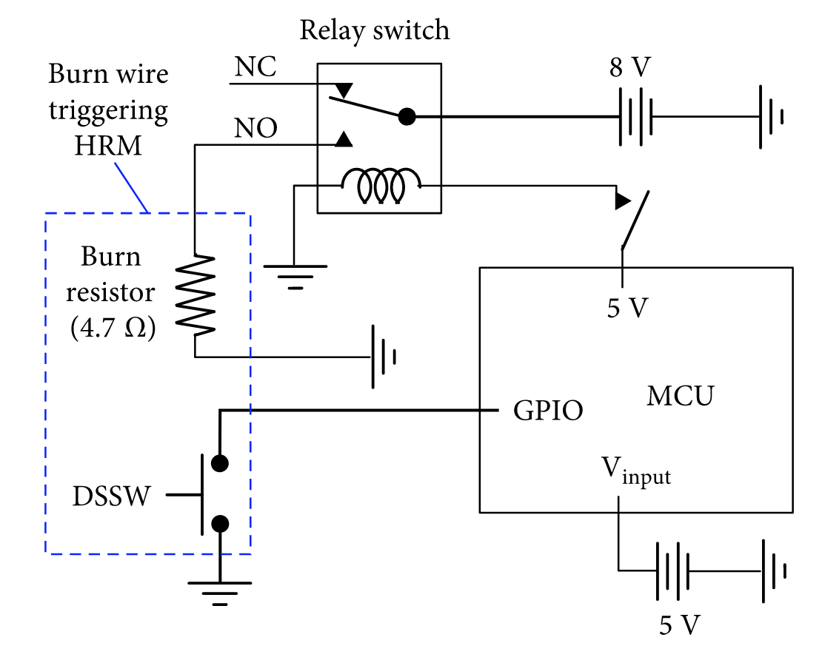

*Figure: Diagram of circuit power cut-off for the burn resistor*

Above is the final design (excluding the exact value of the resistor) of the burn wire circuit that will release the antennae of the CubeSat. The General-Purpose Input/Output (GPIO) of the microcontroller allows for its source voltage to energize the relay. Upon this, the switch of the relay is altered from Normally-Closed to Normally-Open. Then, current is sent through the burn-resistor, heating it as well as the nichrome wire until it is able to sufficiently burn. We can manually add the voltage supply to the above inputs during the testing phase.

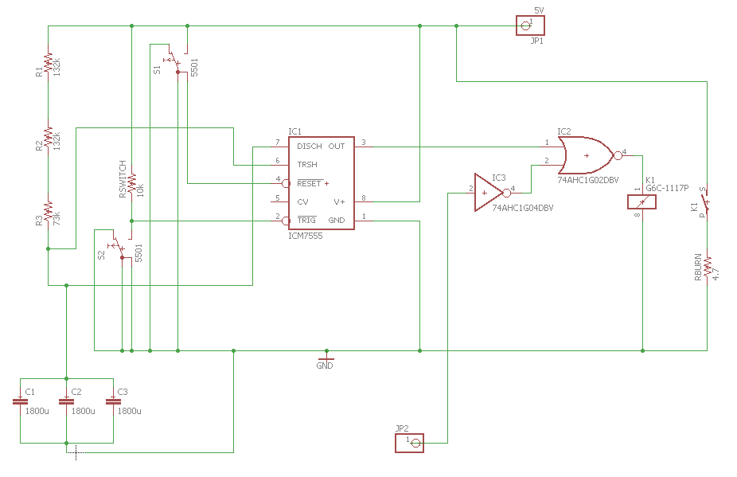

*Figure: Combined timer and burn wire circuit (Created using Eagle Software)*

Overhead is the system combining the 30-minute timer circuit with the burn wire, created via EAGLE, in order to simply find the exact model of the parts needed, as well as cleanly laid out, making it painless to read and analyze. A NOR gate has been implemented to ensure that the burn-wire circuit does not activate until the timer has rundown. It requires confirmation from the timer and the OBC to activate the relay and begin burning the wire.

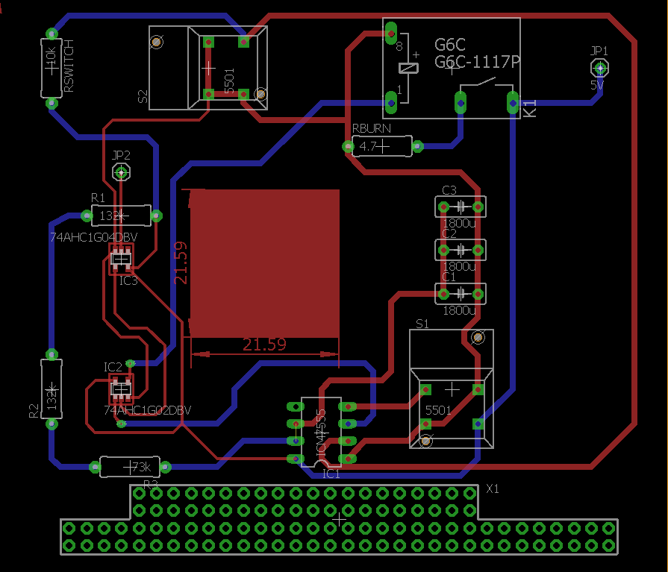

*Figure: PCB Board 1 Design (Created using Eagle Software)*

From the schematic obtained from Eagle, the software allows us to generate and produce an accurate circuit board which is able to be printed. We organized the board to have enough space between for added passive and active elements. This allows for the printed circuit board (PCB) to be easily soldered and begin the implementation phase.

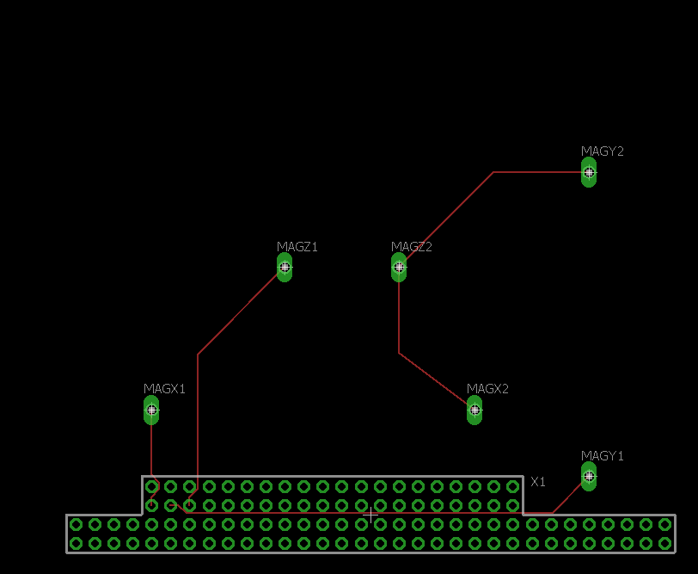

*Figure: PCB Board 2 Design (Created using Eagle Software)*

Board 2 will consist of all the components and sensors that must connect to the PC/104 stack in order to interface with the on-board computer. Currently, only the magnetorquers are displayed, but eventually three gyroscopes, and up to six thermistors will be added once the exact components are confirmed by the other groups. We have selected to place the magnetorquers at the center of the board because it is the most effective point of rotation. Also, this leaves us room at the edges of the board for the sensors. This is ideal as we want readings from each side of the CubeSat for the largest range of data. As soon as the components have been selected, we will work alongside the other capstone group to optimize placement of these components.

# **2. Prototype Fabrication**

*Parts List*

|  |  |
| --- | --- |
| **Part Name** | **Cost** |
| General Purpose SPDT Relay | $2.07 |
| 2 Ohm Resistor (Burn-wire) | $1.16 |
| Texas Instruments NE555DR timer | $0.12 |
| 1800uF Aluminum Capacitor X3 | $0.35 |
| 10kΩ Resistor | $1.44 |
| 73kΩ Resistor | $0.29 |
| 133lΩ Resistor X2 | $0.14 |
| **TOTAL:** | $5.57 |

# Our parts are relatively cheap which is ideal for testing and iteration. In addition to the 75 dollars per team member, CSA is supplying the CubeSat development teams with additional funding to accommodate the higher priced space-rated components. It may also go toward the cost of printing and shipping our PCBs via an external company.

# **3. Validation/Testing Strategy or Protocols**

In order to test the burn wire circuit, all of the parts will be gathered together. The burn wire circuit used for testing will include two 5-Volt power supplies, a general purpose relay, a 2-Ohm resistor, jumper wires, nichrome wire and two clamps. One of the equivalent power supplies will be connected to the coil port of the relay and the other power supply will be connected to the 2-Ohm resistor. This 2-Ohm resistor may be altered in size upon testing, but will remain under a value of 1 kilo-Ohm. The nichrome wire will be in tension using the clamps and in contact with the resistor. The power supply connected to the coil port will be switched on. To simulate the end of the 30-minute timer, the switch of the power supply will be turned on and sufficient current of about 2.5 Amperes will run through the closed switch. The wire will heat up in a matter of seconds from the resistor and successfully cut the wire. This test will validate the design as the cutting of the wire will simulate a wire cut in space. By simplifying the timer process, the testing process can still accurately determine whether the burn wire will be successful. The voltage energizing the relay coil will still be 5 Volts in the test, which is the same as 5 Volts coming from the on-board computer.

The timer circuit will initially be modeled using Microcap, where it will be simulated to confirm the theoretical results found in the initial designing phase. After this, the components will be purchased for practical testing. Since all of them are standard components, we will be ordering them through the department’s parts shop. The circuit will then be constructed on a breadboard, and tested in the engineering lab. After verifying they are within an acceptable range, the tolerances of the components will be recorded, and used to calculate the best and worst case outcomes of our circuit. A 5-Volt source will be used to stand in for the battery of the cubesat, and an LED will be connected to the output of the circuit to visually indicate when the timer finishes. A stopwatch was used to time the performance of the circuit to see how compares to the theoretical calculated results, and ideal simulation. These results will then be submitted and discussed to our advisor, to ensure they are appropriate for our application.

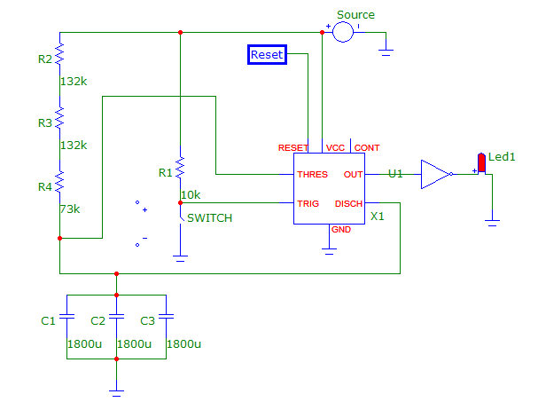

*Figure: Timer circuit design, including testing LED (Created using Microcap software)*

Once the breadboard design has been completed, and we are happy with the values we are receiving, we will move forward with the testing of the PCBs. We plan to outsource the PCB creation to a third-party for the sake of convenience and quality. Upon acquiring the PCBs, we will test the boards’ connections using a multimeter, before finally connecting it to the on-board computer (OBC) to see if it properly interfaces with that system. We will need to verify that each of the sensors and components in the cubesat can communicate with the OBC, while meeting our 30 minute delay criteria. Ideally, the first PCB design will work as intended, but in the case that revisions must be made, PCBs are relatively cheap and quickly delivered.

**4. Preliminary Validation and Results Analysis**

There have not been any conclusive results for the burn wire circuit as the parts have yet to come in. Once we complete the testing process, we hope to implement the circuit in the final prototype on the PCB (Printed Circuit Board). We expect this process to go on for a month.

The initial results of the timer circuit testing were as expected. We were unable to obtain an inverter to be used during testing, so we reversed the test, having the LED being lit up for 30 minutes, and then watching for when it turned off. We also added voltmeter across the LED as a second check to confirm the circuit was running properly, as well as to monitor the actual value of the output voltage. The circuit activated after approximately thirty minutes, stopping power to the output and turning the LED off. The slight deviation from the ideal thirty minute mark is due to the components used not being ideal, nor having tolerances as small as the final parts that will be used. The circuit also did not activate early, which confirmed the design being based around the minimum values of components, rather than their given values in order to avoid this. The success of these results means we can move forward with testing this circuit’s integration with the other confirmed components on our board to ensure they do not only work properly with them, but also integrate spatially onto the board. We will also begin sourcing the final space rated parts that will be purchased and used in the final design.

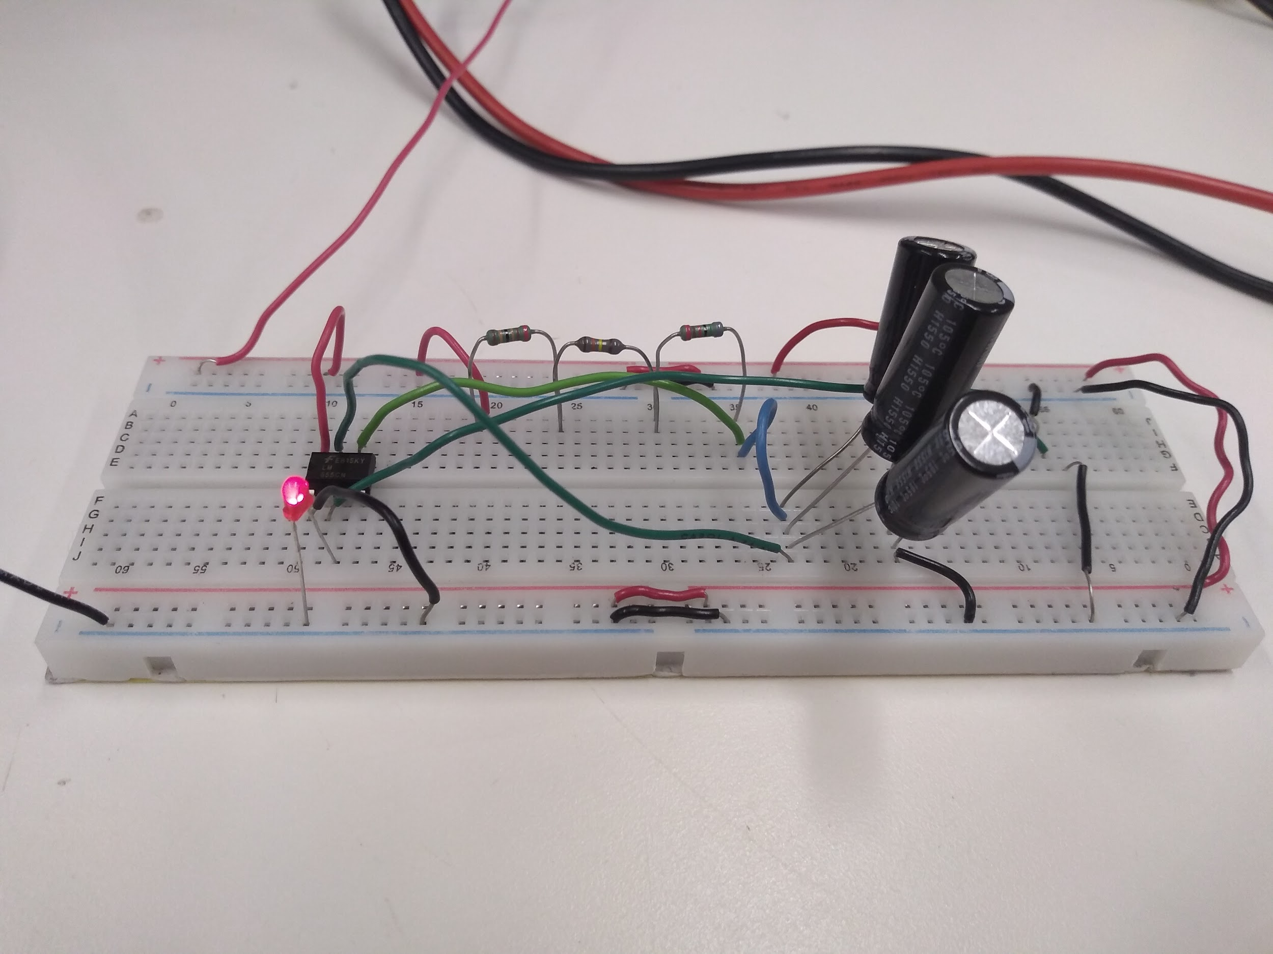

*Figure: Assembled timer circuit for testing*

# **5. Conclusion**

Currently, our project is on track to be completed by the end of the year, as well as meet the overall cubesat project’s timeline. After confirming the portions of the custom boards that we designed are working as intended, we next need to integrate them with the existing components of the cubesat, on and off of our board. This includes the magnetorquers, gyroscope, and on board computer (OBC). We will be contacting the other groups working on these components of the cubesat for additional details moving forward. We will also begin testing aspects of our design past their functionality, such as vibration, heat resistance, and other requirements for going to space.